**CHRISTCHURCH COMPETITIONS SOCIETY INC.**

### SENIOR VOCAL SECTION

**2nd, 3rd, 4th June, Queens Birthday Weekend 2018**

**ADJUDICATOR: Merlyn Quaife MA - Sydney**

**VENUE: Knox Church**

**Cnr Bealey Ave and Victoria St**

**ENTRY FEES:** $6.00 (incl. GST) – Seniors, 18 yrs and over as at 1st June 2018

$25.00 (incl. GST) – Christchurch Aria Class 133

**ENTRIES CLOSE: 17th April 2018 – Late Entries will be considered only at the discretion of the conveners.**

**CONVENER:** Sally Binnie - Tel: 027 4061 061

**Co-CONVENER:** Elisabeth Alberts – Tel: 358 1155, 021 1056 791

Entries **MUST** include **ALL** titles.

Please ensure that information is legible, with details printed, NOT written. When entries are numerous, please use a second form to improve legibility.

**TIME LIMITS: Class 133 Aria (8 minutes). The Adjudicator has the option of ringing the bell to stop the performance when the time limit has been reached.**

**Music: Copies for the Adjudicator must be handed in 10 minutes before class commences and each piece for individual classes must be separated and labeled with the competitor’s name, number and Class No. clearly printed on the front. Please ensure that Adjudicator copies are unmarked and without loose pages.**

**No CD backing tracks are allowed at the Christchurch Vocal Competitions. A number of accompanying pianists are available in Christchurch and we can pass on their contact details if you require a pianist.**

**ELIGIBILITY OF ENTRANTS:** **(Note this replaces Clause 1 (c) of the Christchurch Competitions Society General Conditions and applies to the Vocal Section only).** Any entrant who, with the exclusion of Seminars, Summer Schools and Masterclasses, has been taught by the Adjudicator at any time during the two year period immediately prior to the Competitions shall **NOT** be eligible to compete.   The Executive shall decide the eligibility of any entry and may decline to accept it.  The receiving of any entry in good faith at the Society’s Office does not imply acceptance.  Compliance with the conditions relative to any entry is the responsibility of the entrant.  Enquiries regarding eligibility should be addressed  to the Convenors.

**CLASS ORDER: The order of classes in this Syllabus will not be the order in the final programme. That will be determined by the number of entries in**

**each class and the times available.**

**FOLK CHOICES: A national song by an unknown composer and arranged by someone else. Show this in your entry; eg O Waly Waly – arr. Britten.**

**CHRISTCHURCH ARIA: Upon entering your Christchurch Aria Class 133 choices on the entry form, we also require on separate cover the title of each Opera and a short synopsis.**

**Only arias nominated on the entry form are to be performed. No changes are permitted, unless under extenuating circumstances and approved by the Adjudicator.**

**It is a pre-requisite for the Christchurch Aria class for you to enter**

**Lied, Art Song AND Oratorio Class whether it be Open or 18 – 21.**

**ACCOMMODATION: Entrants from outside of Christchurch requiring accommodation are invited to contact the Co-Conveners.**

**PRIZE MONIES: Prize monies awarded are subject to suitable donations being received. The Society reserves the right to alter or amend any prize monies awarded in any class.**

**ITEM CHANGES: Changes can be made but once the Programme has been printed then the option to change is not permitted, unless approved by the Conveners and the Adjudicator.**

**PROGRAMME: The Senior Vocal Section Programme will be available for download from the Christchurch Competitions Society website:** [**www.chchcomps.org.nz**](http://www.chchcomps.org.nz) **or can be purchased in hardcopy for $5.00 (see entry form)**

**GENERAL CONDITIONS: These are attached to the Syllabus, and must be read carefully.**

**PACANZ: National Young Performer Awards - Society Nomination:- Each Society which is a financial member of PACANZ, may nominate up to two competitors, which shall be selected by the adjudicator. The adjudicator will determine that a competitor has displayed a sufficient standard of performance to competently represent that society at the National Finals.**

**The standard required will be at the absolute discretion of the adjudicator but will include:-**

* **A demonstration of adequate preparation**
* **An authority of performance**
* **A performance with a level of maturity commensurate with a national final competition of this age group.**

**If the adjudicator considers that sufficient stand has NOT been reached by any competitor (entered in PACANZ), then NO nomination will be made.**

**2018 Criteria for Vocal**

**A. Performers shall be 18 and under 25 years as at 1st of October 2018**

**B. To enter and to be considered as a nominee at the Christchurch Senior Competition you must enter:- 1. 20th or 21st Century Art Song (Class 123), 2. A Lied (Class 131), 3. Own Selection (Class 126).**

**If chosen as a nominee for the Christchurch Society, the nominating Society is responsible for paying part of the entry fee National Young Performer of the Year Award i.e. $75.00 inc gst.**

**The nominee is responsible for paying part of the entry fee to the National Young Performer of the Year Award i.e. $75.00 inc gst.**

**The soloists for Ballet, Tap Dance, Pianoforte & Vocal Sections will have Registration and Orientation on Friday 19th October, with the Soloist Competition of Preliminary rounds being held on Saturday 20th October and Sunday 21st October. Soloist Semi-finals will be held on Sunday 21st October, with the FINAL CONCERT at 7.30pm Sunday 21st October (Tauranga).**

**During the Preliminary rounds the performer shall introduce their items and they must sing them in the language in which they were composed.**

**Each performer will perform a programme of a maximum of 15 minutes and not less than 12 minutes, including the introduction. There will be a percentage mark given for the complete programme. A penalty of 5 marks will be deducted if the time limit is exceeded by 60 seconds or more. An accompanist is provided but Competitors may bring their own at their own expense.**

**Each performer will perform a programme consisting of:-**

1. **20th or 21st Century Art Song**
2. **A Lied**
3. **Own Selection**

**In the semi-final, those performers recalled will perform two or three items from their programme. This will be at the Adjudicators’ discretion. Competitors will be chosen based on their marks in the Preliminary round.**

**Three performers will be recalled for the Final Award Concert and will perform one item of their own choice from their original programme.**

**Direct Entry Nomination – Christchurch Competition**

**If the adjudicator considers that more than two competitors have reached a sufficient standard, the adjudicator may report to the committee (conveners) that those competitors should be given the option of a Direct Entry Nomination.**

**The Direct Entry Nominee will be responsible for paying the full entry fee i.e. $250.00 incl gst**

**For Further information please refer to the attached “NATIONAL YOUNG PERFORMER AWARDS 2018 CRITERIA FOR VOCAL” direct from PACANZ.**

**The Christchurch Competitions Society wishes to express its gratitude and appreciation for the generous support of the following sponsors of the 2017/18 Vocal Section:**

The Dame Malvina Major Foundation Christchurch Aria (Class 133) is sponsored by The Dame Malvina Major Foundation and Pegasus Bay Winery.

Dame Malvina Major Foundation

Pegasus Bay Winery

Anna and Vernon Midgley

Judy Bellingham

Christchurch Competitions Society

Christchurch Travel Club

Christchurch Scottish Society

Daphne Pringle

Elisabeth Alberts

Elizabeth Moolenaar

Gillian Wess

j0360800Jamie Ling

Jillian Hewson

Judy Bellingham

Margaret Naismith

Margot Button

Marilyn Davies

Michelle Haskett

McKessar Family

Nan Anderson

Showbiz Christchurch

Teresa McMahon

The Opera Foundation

The Christchurch Liedertafel Male Voice Choir

### OUR SENIOR SECTION ADJUDICATOR:-

Merlyn Quaife AM

A performer of great versatility, the distinguished soprano Merlyn Quaife has performed opera, oratorio, Lieder, chamber music and contemporary music to great acclaim throughout Australia, Europe and the USA for over forty years. She has also performed as soloist with the Singapore Symphony and the Voronesz Philharmonic (Russia). She has appeared with all the State Opera Companies in roles ranging from the bel canto Lucia (Lucia di Lammermoor) to the minimalist Chiang Ch’ing (Nixon in China). She has performed with all the Symphony Australia orchestras, featured in repertoire of every conceivable style from Handel to Ligeti. She has recorded a number of CDs including ‘Aria for John Edward Eyre’ by David Lumsdaine which won her a Sounds Australia Award, she also appears on Naxos, Move, Tall Poppies and ABC Classics. Merlyn is a regular soloist at St. Francis Church (Melbourne), a role she has enjoyed for many years. She has had the privilege of performing twice under the baton of Vladimir Ashkenazy and the SSO. In 2004 she combined her two loves, horses and singing, performing the fiendishly difficult Queen of the Night on horseback. In 2013 Merlyn sang Ortlinde in ‘Die Walküre’ in Opera Australia’s acclaimed RING CYCLE. In the same year she was made a Member of the Order of Australia (AM) for ‘services to music’. From 1995-2007 she headed the Vocal Department at the Faculty of Music, the University of Melbourne. In 2014, Merlyn was been appointed Associate Professor at Monash University, in charge of the classical voice program. She is currently leading an innovative program unique to Monash but inspired by programs in Europe and the USA linked with her considerable experience as an educator. Since 2009, with associate artist, Andrea Katz, Merlyn has been doing recitals to raise funds and awareness for ACRATH (www.acrath.org.au). She is also a foundation member of ‘Songmakers Australia’, a vocal ensemble which performs rarely heard Art Song repertoire and premieres new works composed for the ensemble.

For more information on Merlyn Quaife see [www.merlynquaife.com](http://www.merlynquaife.com)

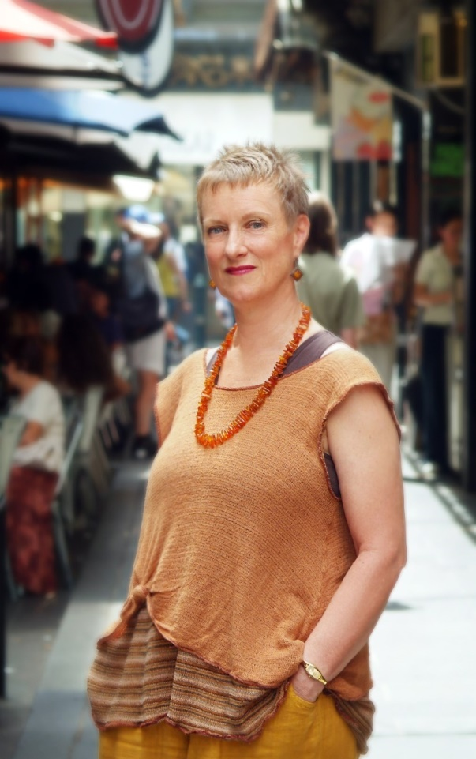

**18 And Under 25 Years:**

**120 Folk/Traditional**

**1st $20 2nd $15 3rd $10**

**121 Oratorio**

**1st $20 2nd $15 3rd $10**

**122 Music Theatre**

**1st $25 2nd $15 3rd $10 (*Sponsored by Christchurch Travel Club)***

**123 20th or 21st Century Art Song –**

**1st $20 2nd $15 3rd $10**

**124 JOAN & BILL DAVIES MEMORIAL SCHOLARSHIP**

**Age 18 & under 21**

***Entrants to sing 2 songs – Criteria = 2 contrasting songs.***

***a)……………………..***

***b)……………………..***

**1st $300 2nd$150 3rd $50**

**(*Sponsored by Judy Bellingham, Teresa McMahon, Marilyn Davies*)**

**Open Classes:**

**125 Duet**

**1st$50 2nd $30 3rd$20**

**126 Gunner Memorial Prize – Own Selection**

**1st$50 2nd $30 3rd$20 *(Sponsored by Daphne Pringle)***

***Daphne Pringle Cup***

**127 ANNA & VERNON MIDGLEY SCHOLARSHIP CLASS**

***a) Operatic Aria***

***b) British Art Song***

**1st$300 2nd$150 3rd$50**

***The Marcus Cup***

***(Sponsored by Anna & Vernon Midgley, Elisabeth Alberts)***

**128 British Folk Song**

**Scottish, Welsh, Irish, English**

**1st$50 2nd$30 3rd$20**

***(Sponsored by Nan Anderson and the Scottish Society)***

**129 European Art Song in the original language**

**1st$50 2nd$30 3rd$20 *(Sponsored by Jamie Ling)***

**130 Music Theatre Solo**

**Can include Light Opera, Music Comedy, Gilbert & Sullivan etc**

**1st$50 2nd$30 3rd$20 *(Sponsored by Showbiz Christchurch)***

**131 German Lieder – Open – Lieder Own Selection**

**1st$50 2nd$30 3rd$20**

**132 Oratorio**

**1st$50 2nd$30 3rd$20 *(Sponsored by Margaret Naismith)***

**133 The Dame Malvina Major Foundation Aria – please see the next page.**

**Aria competitors to enter any Lied, Art Song AND Oratorio**

**134 The Christchurch Liedertafel Male Voice Choir Class – Open**

**Two Art songs – one English, the second, any other language**

The Board of The Christchurch Liedertafel Male Voice Choir are providing a prize of **$500** for the best Canterbury born male vocalist. The winner of this class is asked to perform as a guest soloist at a Liedertafel Concert in August or November 2018.

***Pre-requisite classes to enter if you wish to enter for consideration into the National Young Performer Awards 2018 = 123, 131 and 126***



By entering these competitions Christchurch Competition Society has permission to use my photograph, and/or video and audio recordings, likeness, profile and/or story in this and future competitions, web pages and other promotional materials produced, used by and representing Christchurch Competitions Society. I understand the circulation of the materials could be worldwide and that there will be no compensation to me for this use.

**Class 133**

**THE DAME MALVINA MAJOR FOUNDATION ARIA**

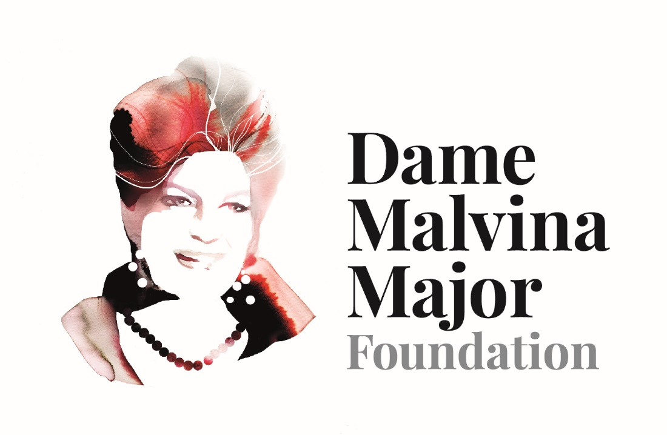

**The Dame Malvina Major Foundation 1st Prize: $5,000\***

**2nd Prize: $2,500 to be confirmed**

**The Pegasus Bay Winery 3rd Prize: $500**



**Pre-requisite classes: aria competitors to enter any Lied, Art Song AND Oratorio class**

**Competitors are to nominate two arias both of which are to be sung in original language and the original key. The time limit for each aria is 8 minutes. Competitors will sing one aria in the heats and those competitors recalled for the final will sing both arias. The Adjudicator has the flexibility to recall 6 or more finalists. Titles of both arias and operas to be listed on entry form (no changes are accepted after the programme has been printed). Only the arias nominated on the entry form are to be performed unless extenuating circumstances are recognized by the adjudicator. The Competitor may decide which of their 2 arias included on the entry form, they will perform at the preliminaries.**

The Dame Malvina Major Foundation is to provide the first prize of $5,000 ($3,500 cash and $1,500 to go towards expenses for the winner to participate in the New Zealand Aria in Rotorua in late October/November 2018). The inability of the winner to attend the new Zealand Aria for valid reasons (e.g. due to commitments that cannot possibly be changed or such as previously winning the New Zealand Aria competition) will mean that $1,500 will be available to the winner for a significant career development project approved by The Dame Malvina Major Foundation

**CHRISTCHURCH COMPETITIONS SOCIETY**

**SENIOR VOCAL SECTION ONLY**

### ENTRY FORM - 2018

**NAME: TEACHER’S NAME:**

**DATE OF BIRTH: ADDRESS: _______________________________**

**ADDRESS:**

**______________________________________ PHONE: ______________________________**

**PHONE:______________________________ EMAIL: ______________________________**

**EMAIL: ______________________________**

**PLEASE PRINT CLEARLY IN CAPITALS. USE ADDITIONAL FORM AS NECESSARY*.***

***Once items are printed in the programme no change is permitted***

|  |  |  |  |  |  |  |
| --- | --- | --- | --- | --- | --- | --- |
| **CLASS NO** |  | **TITLE (ALL Titles to be included)** | | **COMPOSER** | **FEE** | |
|  |  |  | |  |  | |
|  |  |  | |  |  | |
|  |  |  | |  |  | |
|  |  |  | |  |  | |
|  |  |  | |  |  | |
|  |  |  | |  |  | |
|  |  |  | |  |  | |
|  |  |  | |  |  | |
|  |  |  | |  |  | |
|  |  |  | |  |  | |
|  |  |  | |  |  | |
|  |  |  | |  |  | |
|  |  |  | |  |  | |
|  |  |  | |  |  | |
|  |  |  | |  |  | |
|  |  |  | |  |  | |
|  |  |  | |  |  | |
|  |  |  | |  |  | |
|  |  |  | |  |  | |
|  |  |  | |  |  | |
|  |  |  | |  |  | |
|  |  |  | |  |  | |
| **POST ENTRIES TO: Sally Binnie** **3 Chilcombe St, Ilam, Christchurch**  PH: 027 4061 061  [salbinnie@hotmail.com](mailto:salbinnie@hotmail.com)  **ENTRIES CLOSE: 17th April 2018**  **FEES: Ordinary Classes: Senior $6.00incl GST**  **Class 133 Aria $25.00incl GST**    **Cheques must be made payable to “*Christchurch Competitions Society Inc”.***  ***There shall be no refund of money***  **DIRECT CREDIT:**  **CHCH COMPETITIONS SOCIETY;**  **WBC 03 1707 0037805 000**  **Enter competitor’s surname and VO in reference column. For entry to be valid your form must be emailed/posted the same day.** | | | **SUB – TOTAL** | | **$** | |
| **Administration (including PACANZ Levy) - See General Conditions** | | **🗸** | **15.00** |
| Vocal Programme free to download at www.chchcomps.org.nzHardcopy of Programme | |  | **5.00** |
| ***This year all sections are trialing a gold coin donation as admission to all sessions.***  ***DONATION* – To ensure that a prize is available for every Class, Donations from competitors and their families are important. Your contribution, however small, will be most appreciative.** | |  |  |
| **TOTAL ENCLOSED** | |  |  |